Quarterly Report – Public Page

Date of Report: 2nd Quarterly Report, March 26, 2024
Contract Number: 693JK32310010POTA
Prepared for: Government Agency: DOT and Co-funders
Project Title: Standardize the Application of Vapor Corrosion Inhibitors
Prepared by: Pipeline Research Council International (PRCI), Inc.
Contact Information: Janie Norton, jnorton@prci.org 703-205-1600 ext: 105
For quarterly period ending: March 30, 2024

1: Items Completed During this Quarterly Period:
Item # | Task # | Activity/Deliverable | Title | Federal Cost | Cost Share
7 | 5 | 2nd quarterly status report & project management | Submit 2nd quarterly report | $7,985 | $1,996

A subcontract with Battelle Savannah River Alliance (BSRA), LLC. has been signed. Team to hold kickoff meeting 4/3/24 and started literature review of the VCI qualification and related testing methods.

2: Items Not-Completed During this Quarterly Period:
Item # | Task # | Activity/Deliverable | Title | Federal Cost | Cost Share
1 | 5 | Kick-off meeting with all stakeholders | Meeting summary and action items to be included in the quarterly report | $7,644 | $1,911
2 | 1 | Conduct literature review of the VCI qualification and related testing methods | Summary of the literature review to be included in the first quarterly report | $10,424 | $2,606
4 | 2 | Development of the test matrix for VCI qualification tests | Summary of the test matrix to be included in the quarterly report | $12,000 | $3,000
5 | 2 | Procure materials and supplies for the VCI qualification testing | Summary of the materials and supplies to be included in the quarterly report | $87,640 | $21,910
6 | 3 | Initiate Control Tests | Summary of the control tests started in the second quarter to be included in the quarterly report | $16,000 | $4,000

The project is behind schedule due to contracting delays between PRCI and BSRA.

3: Project Financial Tracking During this Quarterly Period:
Note that this chart reflects Federal share only:
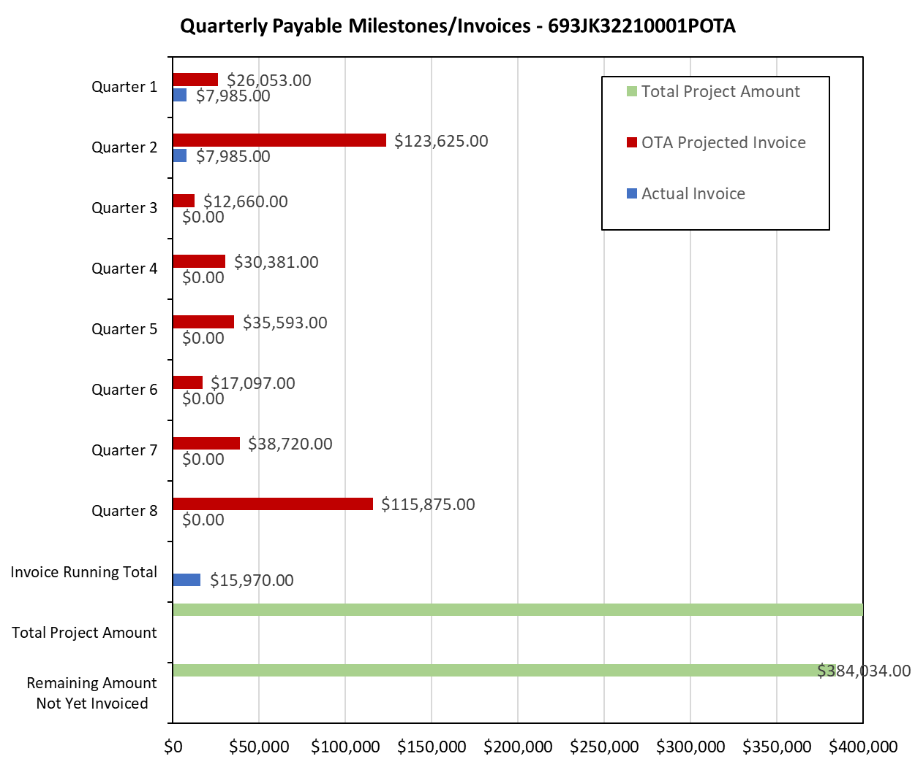

4: Project Technical Status –
Team to hold kickoff meeting 4/3/24 and started literature review of the VCI qualification and related testing methods.

5: Project Schedule –
The project is behind schedule. The project team plans to catch up as much as possible in the next quarter.

